
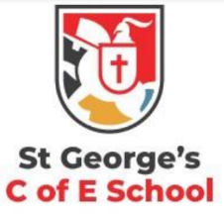
Prediction
Questions to develop prediction skills
What do you think is likely to happen with ___?
Why do you think ____?
Based on what you know about ___, what do you think they will do next?
Do you think the author has a plan for ___?
Do you think this character will change their behaviour in future? Why or why not?

A guide for parents to support your child to strengthen their reading comprehension skills KS2.
Prediction
Prediction involves making a logical and reasonable guess about what might happen next. Your child will need to understand what they have read in order to use contextual clues to make a sensible prediction. For example, the text might state:
Ranvi looked out of her window at the pouring rain
Your child might predict that Ranvi will choose to stay indoors or that she will pick up her umbrella to go outside. It’s a good idea for your child to use ‘because’ in their answer in order to show the evidence for their prediction.

Vocabulary
Questions to develop vocabulary skills
Which word is the closest in meaning to ___? What does ____ mean in this sentence?
Can you find and copy a word or phrase from the text that means the same as ___?
Find and copy two words from the text which show that the character is feeling ___.
Can you choose the best word to describe ___?
Vocabulary
Vocabulary skills are important for ensuring that your child understands the meaning of what they are reading. They will need to use contextual clues to work out the meaning of words they might not know. For example, the text might state:
Bella accelerated, the streets becoming a blur.
Your child might be asked to choose which word from a selection of words is the closest in meaning to accelerated. They should be able to use the clue of the streets becoming a blur to let them know that it means sped up.

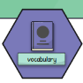

Summarising and Sequencing
Questions to develop summarising and sequencing skills
What is the main theme or message of this paragraph/chapter/text?
Can you describe what happened in this chapter?
How would you sum up __?
Can you order the events of this chapter? Can you number the events in the order they happened?
What happened after ___?

Summarising and Sequencing
Summarising is the skill of identifying key points in the text and summing up what you have read.
Your child will need to have a good understanding of what they have read in order to pick out what is the most important information. They might also be asked to think about the overall theme of the text or to describe what has happened in a small number of words.
They will be able to use the hashtag summary strategy.
#summarise in 6 words or less
Sequencing is related to summarising. Your child will need to be able to identify the order in which events happened.

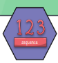

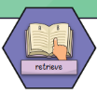
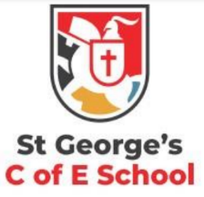
Retrieval
Questions to develop retrieval skills
Which paragraph/sentence/phrase tells us ____?
Who are the key characters in the text?
Who is telling the story? How do you know?
Where/when is the story set? How do you know?
Find and copy a word that tells you ____.
Retrieval
Retrieval is the skill of being able to find and extract information from a text. Unlike inference, where the information might be hidden, retrieval questions ask you to find key information that is plain to see within the text. For example, the text might state:
Tobi travelled from London to Brighton by train on Wednesday.
Questions might ask your child to tell them where Tobi was going, where he started from, how he travelled and when he travelled.


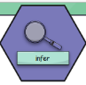
Authorial Intent
Questions to develop authorial intent skills
What does ___ tell us about this character?
Which phrase implies that this character is ___?
Can you find a simile/metaphor in the text? What meaning does this add?
Why did the author choose to use this particular word?
How has the author’s choice of words created a feeling of ___?
Authorial Intent
This skill is important for understanding how the author of a text has used language to convey a deeper meaning. Your child will need to think about why the author has used certain words and phrases and how they give a certain meaning to the text. For example, the text might state:
In the graveyard, the treetops moaned and groaned, their branches stretching out like knobbly witches’ fingers.
Your child might be asked to explain how the author’s use of the verbs moaned and groaned as well as the comparison to witches’ fingers has given the text a spooky feel.

Inference
Questions to develop inference skills
Why does this character do this?
What does this action or description tell us about this character?
Why is this character/setting/object described in this way?
How do you know that this is true?
What evidence is there to support this?

Inference
Inference can be thought of as any step in logic that allows someone to reach a conclusion based on evidence or reasoning. In reading comprehension, this means using what you already know as well as what you can see in the text to come to a conclusion. For example, the text might state:
Sally shivered and put on her coat.
From this statement, we can infer that Sally is cold. The text hasn’t explicitly stated that this is the case but it can be inferred.

