Reading

Home reading
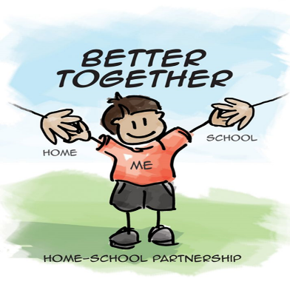
At St George’s C of E Primary School, we value reading as a key life skill and are dedicated to enabling our pupils to become lifelong readers. We believe reading is key for academic success. Reading is one of the most vital activities that your child can do at home as this ensures their access to the wider curriculum. Children should be reading regularly (at least 3 times / week).
Children will be given weekly reading books to be read at home. When your child has read their books, it is very important that you write and sign in your child’s reading diary. This will be checked weekly by an adult in school and children will be rewarded for reading regularly at home.
They will also choose an additional ‘reading for pleasure’ book from the library, which can be enjoyed independently or read by an adult.
Please ensure that your child has their reading book and planner in school daily.

School reading
Year 1: Group guided reading sessions.
Year 2 – 6: Whole class reading sessions.
Children will learn a wide range of vocabulary, echo read, timed read, read without interruption and practise a variety of reading skills and comprehension style questions.
Here is an example timetable for a 2 week cycle of lessons:

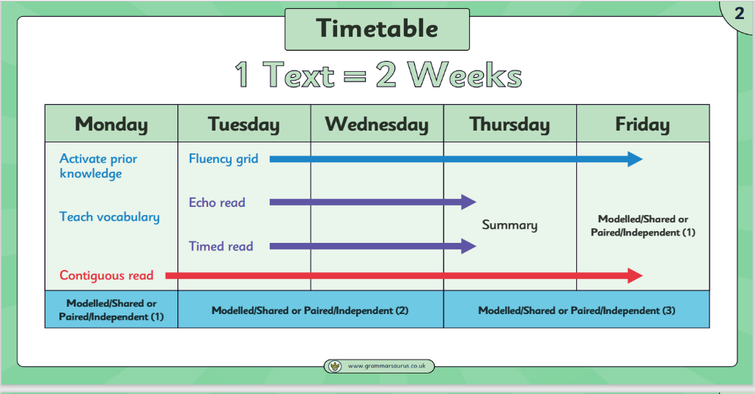

Extra support
Children who require extra support will also receive 1:1 reading with an adult.
Older children will also be ‘buddying up’ with Key stage 1 children to provide extra support.
We also have some volunteers who come in weekly to read with some children.

If you have any queries about your child’s reading, please do not hesitate to contact your child’s teacher.

